Name:نورهان رضا عبد الواحد احمد

Sec:2

BN:30

0.Selection Sort

|  |  |  |
| --- | --- | --- |
| N | Time for random data | Time for sorted data |
| 1000 | 0 | 0 |
| 5000 | 12 | 11 |
| 10000 | 48 | 45 |
| 50000 | 1163 | 1149 |
| 75000 | 2608 | 2606 |
| 100000 | 4667 | 4640 |
| 500000 | 121748 | 118035 |

1.Insertion Sort

|  |  |  |
| --- | --- | --- |
| N | Time for random data | Time for sorted data |
| 1000 | 0 | 0 |
| 5000 | 9 | 0 |
| 10000 | 22 | 0 |
| 50000 | 575 | 0 |
| 75000 | 1293 | 0 |
| 100000 | 2306 | 0 |
| 500000 | 57970 | 1 |

2. Merge Sort

|  |  |  |
| --- | --- | --- |
| n | Time for random data | Time for sorted data |
| 1000 | 0 | 0 |
| 5000 | 1 | 0 |
| 10000 | 3 | 3 |
| 50000 | 20 | 16 |
| 75000 | 31 | 23 |
| 100000 | 40 | 27 |
| 500000 | 221 | 193 |

3. Quick Sort

|  |  |  |
| --- | --- | --- |
| N | Time for random data | Time for sorted data |
| 1000 | 0 | 1 |
| 5000 | 0 | 17 |
| 10000 | 1 | 70 |
| 50000 | 4 | 1891 |
| 75000 | 6 | 4014 |
| 100000 | 9 | 7447 |
| 500000 | 55 | 326701 |

4. Hybrid Sort

|  |  |  |
| --- | --- | --- |
| n | Time for random data | Time for sorted data |
| 1000 | 0 | 0 |
| 5000 | 0 | 1 |
| 10000 | 1 | 1 |
| 50000 | 7 | 3 |
| 75000 | 14 | 4 |
| 100000 | 18 | 9 |
| 500000 | 99 | 49 |

Graph for random data

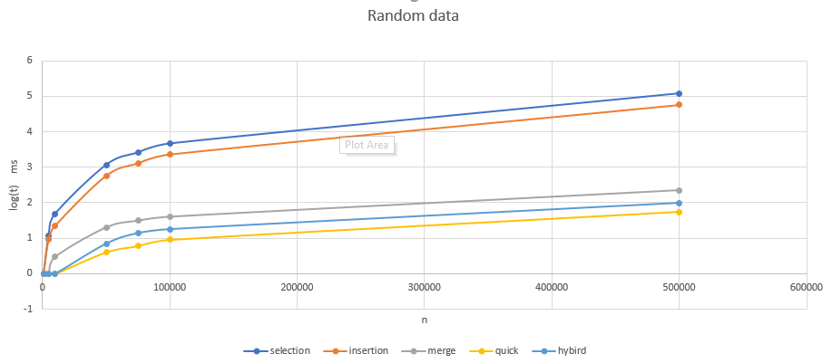

Graph for sorted data

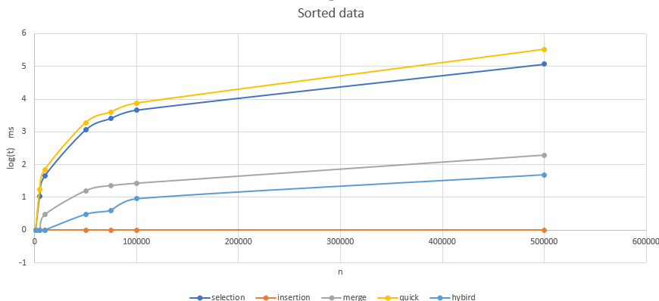

**How I created hybrid sorting algorithm**

from lectures

For small 𝑛, Insertion sort is better while Merge sort is better for

large 𝑛

•For 𝑛=2,10,100, Insertion sort is faster

•For 𝑛=1𝐾,10𝐾,…, Merge sort is faster

I took a threshold value which is 55 In between [2,100] in which insertion sort works better

So if the size of array is larger than 55 I divide the array and sort each 55

And then merge them together

And also the space complexity of insertion sort is better so it will be better for this algorithm

Insertion sort:

* Time complexity T(n)=𝑂(𝑛)
* Space complexity (in place) S(n)=Θ(1)

Merge sort:

* Time complexity T(n)=Θ(𝑛log𝑛)
* Space complexity S(n)=Θ(𝑛)